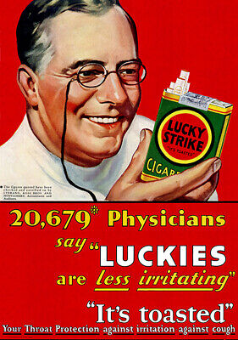

We now know that cigarettes are not just unhealthy, but can become a slow acting poison. But in the past, cigarettes were not as regulated as they are today, and some of their ads reflect this point, as seen in the focus of today's writing, a Lucky Strike Cigarette ad, showing a physician, a statistic, and a declaration that their cigarettes protect against coughs. The audience of this particular advertisement is primarily people who are apprehensive of smoking because of their perceptions of cigarettes being unhealthy. The secondary audience would then be people who may already smoke a different company's cigarettes, who may be swayed by the implication that Lucky Strikes is healthy, but not other companies. I believe this ad is targeted more towards the fence sitters who don't smoke at all, as this gets at the heart of their apprehension.

The purpose of this advertisement is to cement Lucky Strike's position in the cigarette market by raising themselves up while putting down the competition, thereby gaining new customers in not just previous non-smokers, but also making money off of smokers who preferred another brand. Placing a physician implies a testimony of an authority figure for the statement, with or without scientific backing.

Contextually, the reader likely already has the notion that cigarettes are not good for you. This advertisement was a way for Lucky Strike to compete with the much more popular Camel cigarettes. Camel cigarettes at the time had a stronger and "nuttier" flavor, and so were preferred to a lot of the other cigarettes found on the market. Logistically, it was likely impractical to scrap their current formula and tobacco growth in favor of whatever tobacco Camel used, and so instead of making a better product, they just had to convince consumers that they have a better product, and associate their competitors' with health problems.